MINISTRY OF AGRICULTURE, ANIMAL INDUSTRY AND FISHERIES (MAAIF)
TECHINOLOGICAL RESEARCH INITIATIVE AFRICA.

TRAINING REPORT ON PESTCIDE PROPER HANDLING USE, IDENTIFICATION, FUMIGATION

ORGANIZERS.
MINISTRY OF AGRICULTURE, ANIMAL INDUSTRIES AND FISHERIES (MAAIF),
UGANDA WAREHOUSE RECEIPT SYSTEM,
GRAIN COUNCIL OF UGANDA,
UGANDA NATIONAL BUREAU OF STATISTICS,
MAKERERE UNIVERSITY.

INTRODUCTION

Objective.
The training was organized by a combination of government bodies in a fight to control pesticide abuse.
Reduce food poisoning and
Equip different stakeholders with relevant knowledge about the E-Commerce system of Uganda.
Further emphasis was put on miss use of public funds especially in the agriculture department.

When and where
The training began on 8th/08/2022 and commenced on 12th/08/2022 at COLINS HOTEL in Mukono district.

Attendance.
The training was attended by 29 member representatives across the country especially the agronomists, warehouse operators, fumigators and agriculture chemical dealers.

INDIVIDUAL EXPECTATIONS.
- To learn the different chemicals and there formulation and the agriculture sector.
- To help differentiate between safe drugs and fake ones on market to help our farmers reduce costs and losses on fake in puts
- To get refreshed onto the pesticide rules and regulations in Uganda.
- Individual role of stakeholders in the safe use of pesticides.

ACHIEVEMENTS.
- Was able to identify and classify at most all the pests around a farmer i.e. a Weed, insect and insect like, disease pathogens and vertebrates and further studied them at length.
- Was able to learn how to identify different pesticides in accordance to the role i.e. herbicides for weeds, fungicides for fungi insecticides for insects etc.
- Was able to revise some of the pesticide rules and regulations in agriculture chemical and the penalty one would get if he/she bleached one e.g. in storage , transportation, registration and usage of the chemicals which would be of a help to my farmers in Masindi to mention but a few

Topics covered include.
- Identification of field pests
- “ of storage pests
- Pest control methods.
- Pesticide rules and regulations in Uganda.
- Classification of pesticides
- Pesticide application techniques for both field and storage pests.
- Principals and practices of fumigation.
- Herbicides and their applications
- Pesticide application equipments
- Pesticide hazards and first aid
- Lastly transportation ,storage and disposal of chemicals

CHALLENGES.
- Late arrival due to the fact that I had to first finalize with my official duties and delegation for those that were incomplete at my work place.
- Inadequate facilitation since it was a personal facilitation.
- Long distance travel that always left me very tired for the day’s work.
- Multiple handling of tasks since I was to still keep handling my employment tasks as had promised in my leave I sought
- Lacked personal gadgets like laptop computer and mobile phone to embrace the new technology in study and implementation of some work.
- False expectations met i.e. no training and transport facilitation given in the long run.

RECOMMENDATIONS.
As to my employers I beg that you also organize one of the trainings to my fellow field staffs to help equip them with same relevant knowledge that I saw was so vital to our farmers.
Organize a side fund to always help facilitate members going to similar trains

CONCLUSION
Special thanks to my bosses at TRI-Africa For letting me take on the opportunity of the study amidst all challenges encountered and pray that all goes on smoothly next time.
More thanks go to my fellow staff who accepted to stand in for me in filling the gap I left for the week.
Hope to disseminate the acquired knowledge to all the relevant person like my farmers in TRI-AFRICA and Masindi at large as well as to my fellow staff members who never attended.

PHOTOS
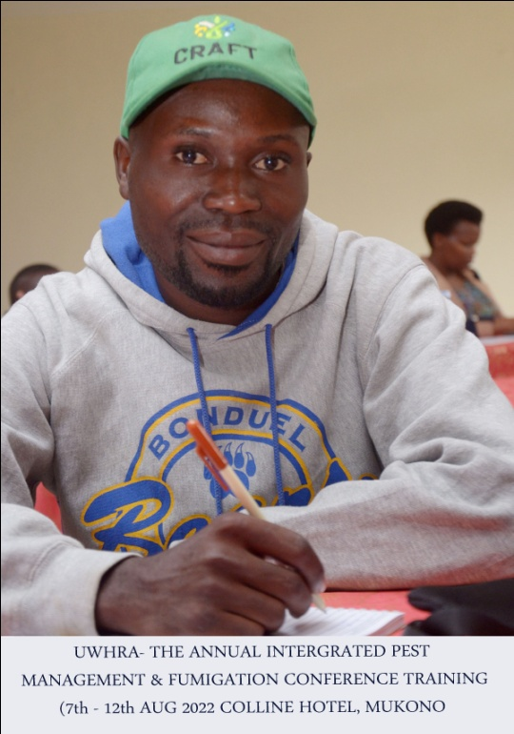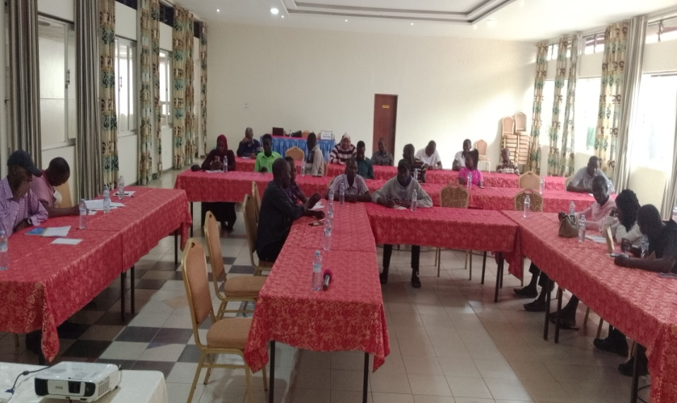
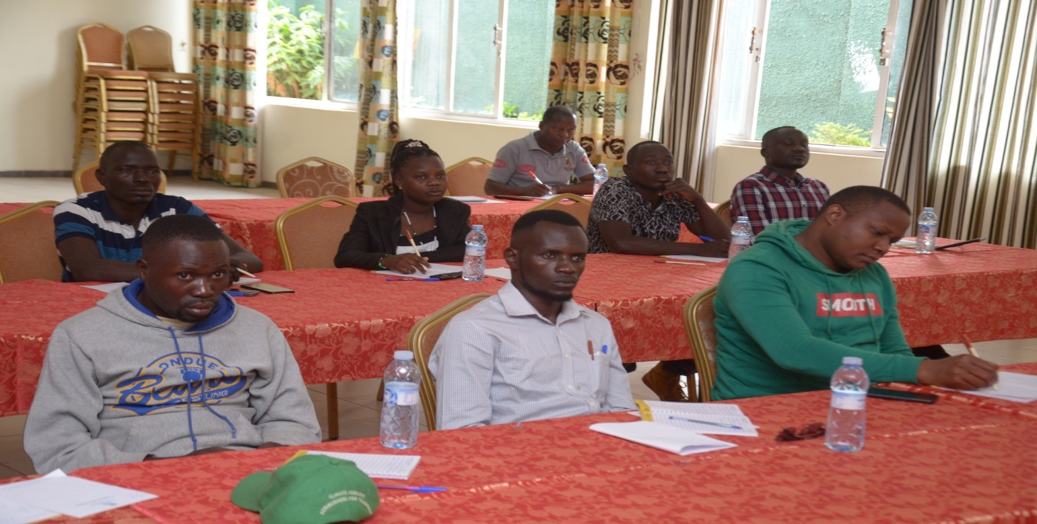

REPORTED BY
ASABA VINCENT

EXTENSION STAFF TRI-AFRICA.

